SOFTWARE ENGINEERING

Section-D Module-01

Submitted By : 211FA04311

Project-02 : ONLINE BOOKSTORE

USECASE DIAGRAM:

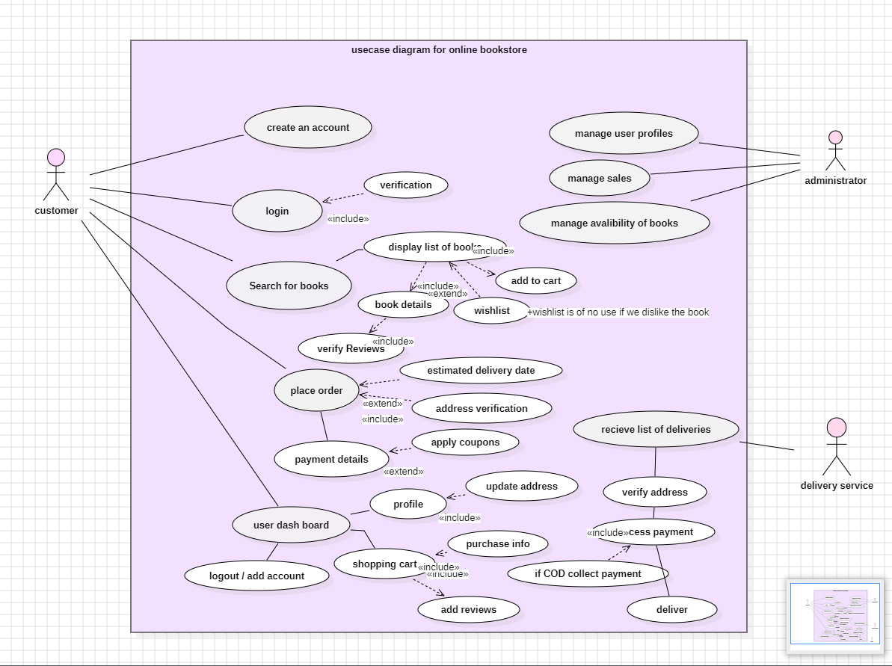

ACTIVITY DIAGRAM:

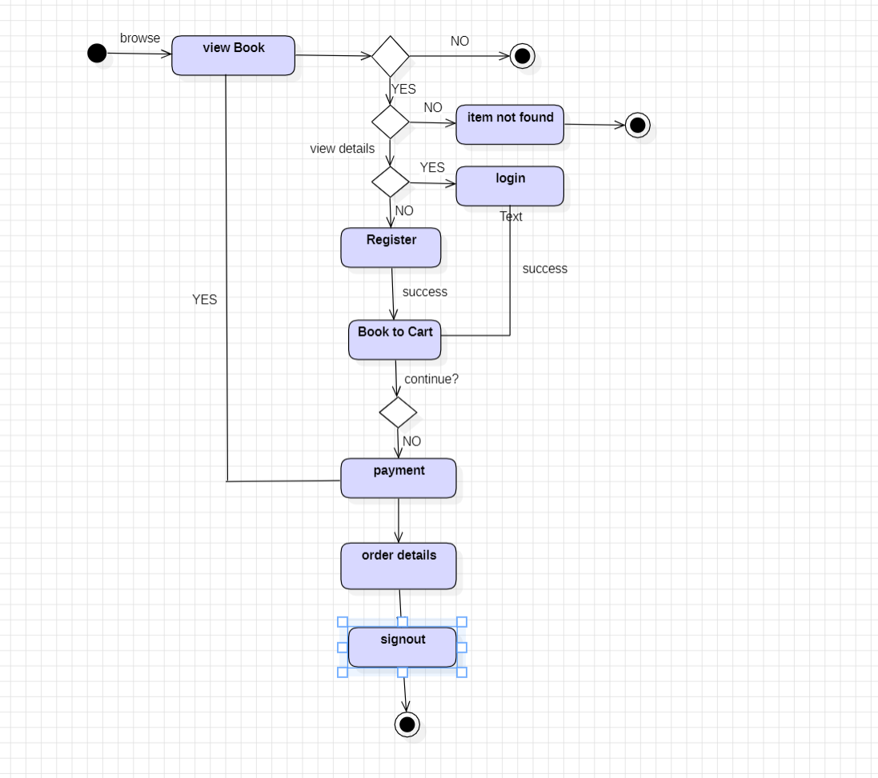

STATE CHART DIAGRAM:

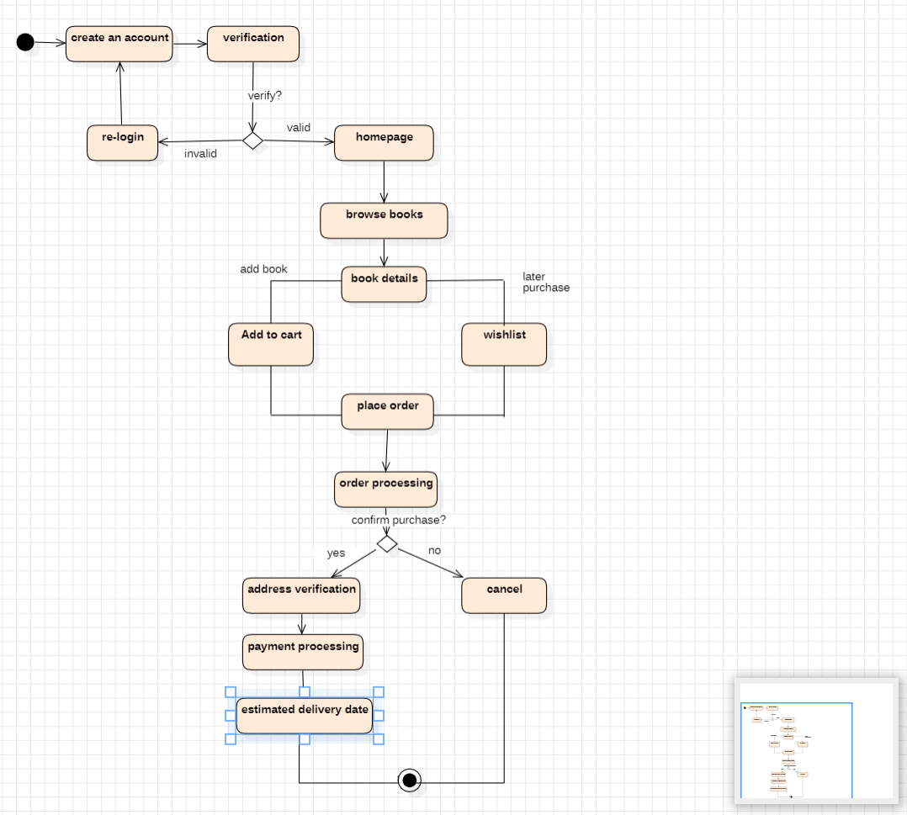

CLASS DIAGRAM:

SEQUENCE DIAGRAM:

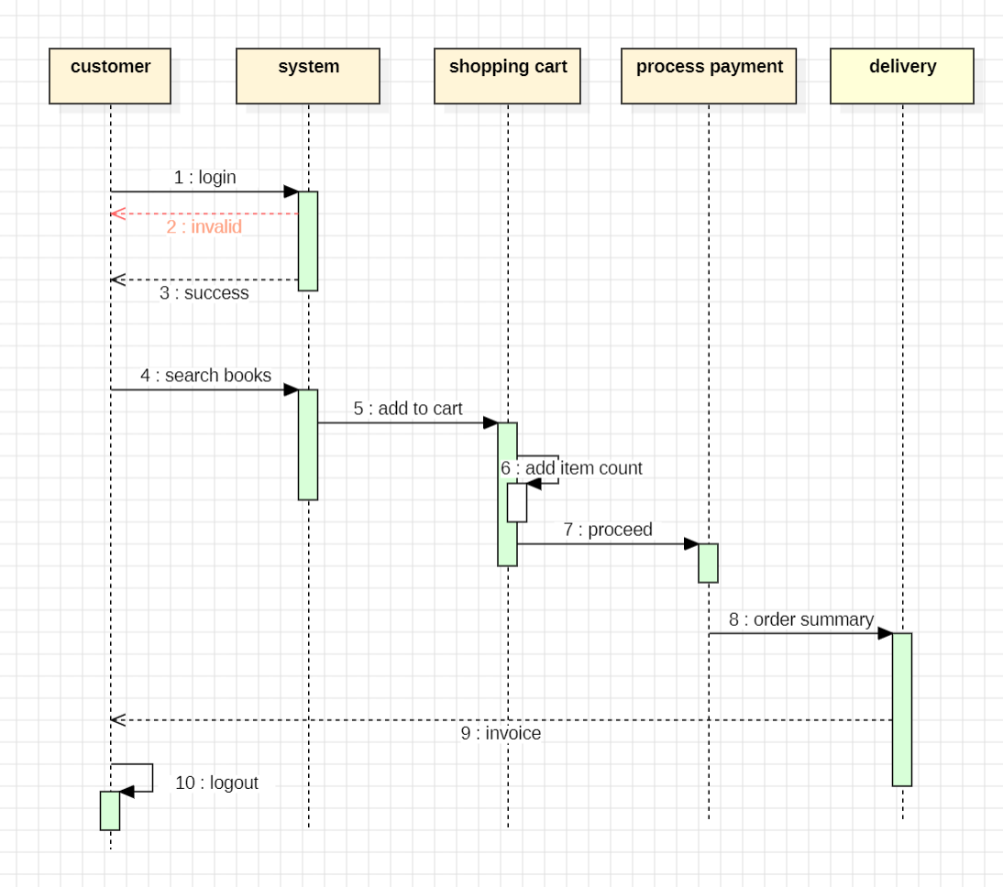

Project : 04 : A MULTI-THREADED AIRPORT SIMULATION

USECASE DIAGRAM:

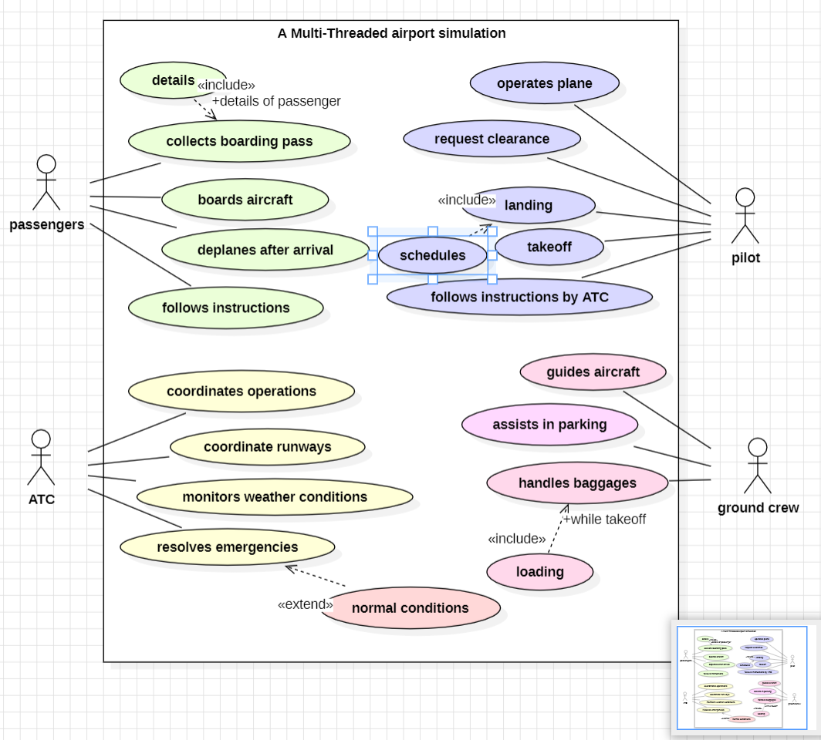

ACTIVITY DIAGRAM:

START CHART DIAGRAM:

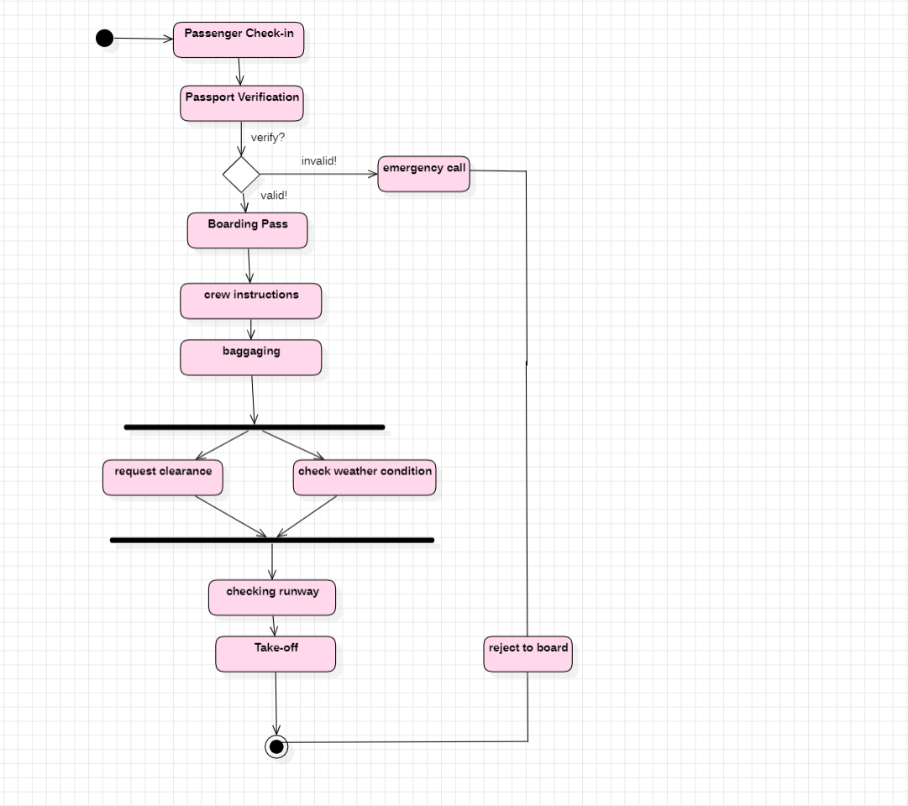

CLASS DIAGRAM:

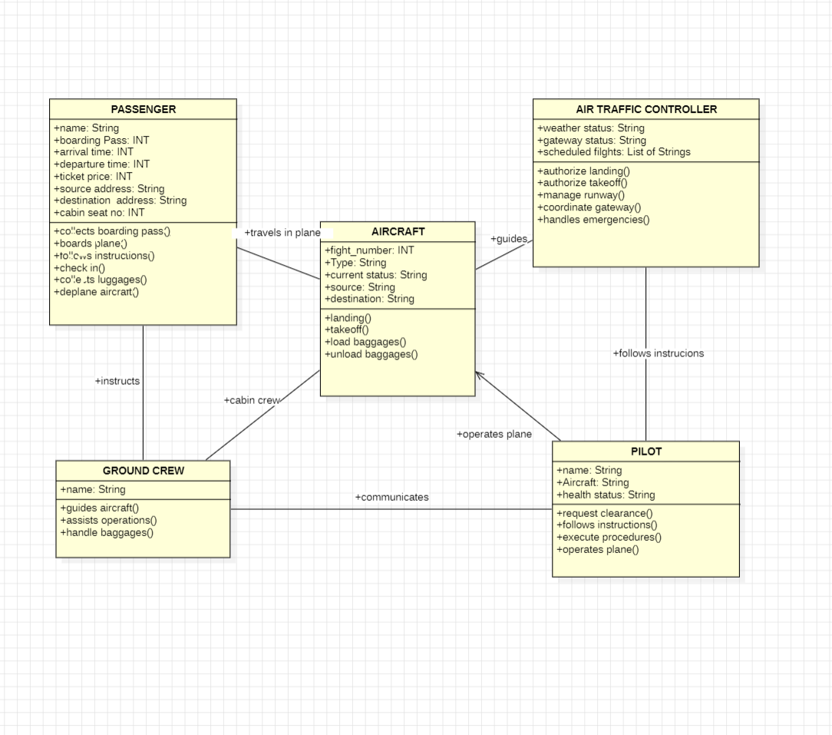

SEQUENCE DIAGRAM:

